1. Lessons Learned from Sprint 4

-------------------------------------------------------------------------------------------------------------------------------------

I learned that it was much easier to join the International Scrum team and integrate my code into their website to add more functionality. They already had code and I was able to work with Soungyoung on the webpage as well.

I thought the app for sprint 4 wasn’t bad at all. It didn’t require much hard work since I mostly just modified my existing code to work with team International scrums code.

I noticed some bugs and logic errors before the sprint. So, I reverted to an older version that didn’t include the progress bar and SoungYong’s code. But I managed to get the progress bar back in and fixed the program to the point where I didn’t notice any bugs or logic errors.

So, to help prevent this issue I decided to carefully test the app when new code is added. I have increased the number of backups I make so if I find a logic error or bug in the app the backups go back further than just one day. I am also going to look over the code more carefully when a pull request is made by other team members just in case.

-------------------------------------------------------------------------------------------------------------------------------------

4. Code for completed work, with comments at the top clearly indicating which team member wrote the code. Final code should be in GitHub.

<https://github.com/mueller9999/tour-de-stlcc-3_23_2020a>

------------------------------------------------------------------------------------------------------------------------------------------

7.Documentation of the code – what it does, who will use it, and its platform, software/hardware requirements.

------------------------------------------------------------------------------------------------------------------------------------------

What it does

What it does – The user starts at a STLCC Virtual Tour Login screen where they can either enter a User Id and Password and click the Logon button or click the Create New Account button. I copied the html code from another team member to use to get started on this page. On the Welcome to the STLCC Virtual Tour the user ID and Password cannot be blank. The password characters cannot be seen visible on the user’s screen.

If the user clicks the Logon button after entering a valid User ID and a valid Password then they go to a page where they can either update their member data, Start STLCC Virtual Tour or return to the Logon page. If the user entered data for a first name, then they are greeted by a message towards the bottom of the page that says Welcome Member with their name they entered following Welcome Member. Soungyoung added some code to this page to make it better looking. One thing that is noticeable is the text at the top of the page was added. The text is STLCC Virtual Tour member Data. The Member ID field un editable and cannot be changed on this page. Also, the Member Join Date field is un editable and has a date stamp of the date when they created their member account. Changing the First Name field is optional the member does not need to enter a First Name. But they can change their First Name to any characters they want to. With the Password field the user can enter any characters for a password too. The password characters cannot be seen on this page. A number must be entered for the Member Weight field and the password field cannot be left blank. The number variable used for weight is a double variable. Then the user can click the Insert Member data button which will return them to the Logon page if all the data on this page was entered correctly. Error messages are printed below the question printed on this page that asks the user if they want to start the Tour de STLCC. They have the option to click either the Yes Button or the No Button. If the No button is pressed, then the user is returned to Logon page. A link the Logon page is at the bottom of the screen.

When the user clicks on the yes button below the text Do you want to start the STLCC Virtual Tour they are taken to the page I call the main page for STLCC Virtual Tour page. Most of the html code came from the other group members of International Scrum At the top of main STLCC Virtual Tour page in the steps section Welcome User is printed then comes the users first name. below the greeting there is a clock that I added which tells the time including the current seconds. Below the clock Steps is printed and there is a textbox where the user is supposed to enter their steps. To the right of the text box is a calculate button. at the bottom is a link that goes back to the logon page. In the text box the user enters how many steps they walked so far. In the text box the user must enter integer number. The number must be an integer number and must be greater to or equal to zero and less than or equal to the max size for an integer. If the user enters correct input, then their total steps is printed which is stored in the database and a date stamp where the date and time that they first started is printed to the screen. A Return to the Logon page is at the bottom of the page. Also, below the textbox comes a message that prints the percent of the tour that is complete which is also printed in the progress section of the page. Below the text printed about the percent of the tour completed is a progress bar. When the tour is complete the progress bar disappears. Instead when the tour is complete text is printed to the left of the image in the progress section which states that The Tour is complete. After the total steps has been printed how many calories burned is printed. Also, how many steps to go until the next tour place is printed along with the name of the next tour place. If the number of steps exceeds 80,000 a message is printed below the percent tour complete message telling that the limit on steps is 80,000. If the number of steps entered is greater than 80,000 the steps per that click of the calculate button is limited to 80000 and the total steps displayed is incremented by 80000. When the user’s total steps are high enough then You Passed and then the location is printed. Under that the option to see the location or stay on the webpage and clear the messages is printed in the goals section. The Yes button and see location link both go to the same webpage. Which goes to a webpage where there is an image of the place they just passed. Also, there is a link that goes back to the Main STLCC Virtual Tour page and does not clear the messages that are on the main website page. Clicking the No button clears the messages on the main web page and clicking the link to the right of it clears the messages on the main webpage until the calculate button is pressed again. When the user reaches the total amount of steps of the tour then right below the textbox is a message displaying the Tour is complete. That message is also printed in the progress section. When a location is reached it is displayed in the goals section. When the user clicks the Yes button or the see location link then the page goes to that location page at the bottom of each of the location pages there is a button that does the same thing as clicking the back button in the web browser which goes back to the main STLCC Virtual Tour page.

In the place section of the main webpage Soungyoung added the Tour place information. Which was modified by Michael Mueller later because three new locations in between STLCC Wildwood and STLCC Corporate college were added. I added in some links for the three locations to go to webpages. The Butterfly House webpage link goes to the Butterfly houses webpage. I don’t have links for webpages for chesterfield mall and Dates Park.

At the logon page if the user clicks on the new member screen then they can create an account. The fields are Member ID, First Name, Weight and Password. The Member ID field cannot be blank. The password field cannot be blank, and the Weight field cannot be blank. Error handling messages are printed below the Insert Member data button. The Member ID field can have any character in it. The First Name field can have any character in it and the Password field can have any character in it. But the Weight field must be a number that is greater than 0 and cannot be blank. Also, there is a link at the bottom to go back to the logon page. If the Insert Member data button is pressed and there are no errors, then the user is taken back to the Logon page and an account is created.

------------------------------------------------------------------------------------------------------------------------------------------

Who will use it

------------------------------------------------------------------------------------------------------------------------------------------

who will use it-

The project is closer to being finished for users interested in creating an account, logging in to an existing account, modifying their existing account data and going to a page that keeps track of how many steps were taken so far and displays the steps to the user. Also, around how many calories have been burned since the tour was completed. Users can see how much in percent format they are from finishing the tour along with a progress bar and how many steps to the next tour place along with what the next tour place is called. They can also see what locations in the tour they have passed. Right now, I can’t think of anything else to add except for maybe some sort of animation on the logon page.

------------------------------------------------------------------------------------------------------------------------------------------

-its platform/software hardware requirements

The app runs in a browser so possibly if a device uses a browser like Firefox or chrome then they can run the app. I’d like to figure out how to just deploy the project and run it from a computer that is connected to the internet so it can run from a device with a web browser that has access to the internet. Right now, I only know how to run the app from NetBeans and deploy the project and use tomcat to run the computer from my own computer which will run the app in a browser. The project can also run from a flash drive that has netbeans portable, jdk 1.8.0, tomcat and WinNMP installed on it.

So right now, to run the project the minimum software requirements are having tomcat and mysql installed, most likely the java runtime, a web browser and a device that is powerful enough to run the software requirements.

-------------------------------------------------------------------------------------------------------------------------------------

8 ERD (Entity Relationship Diagram) for the database

I didn’t design a database, but I made one in MySQL WorkBench and used the reverse engineer option in database menu to create what I thought could reverse engineer the database to create an ERD.

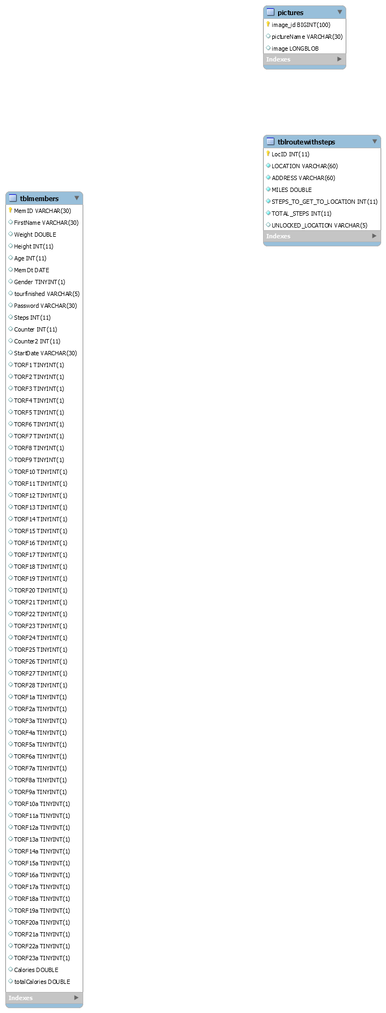

-------------------------------------------------------------------------------------------------------------------------------------

9.

Recommendations for possible additions to Project Scope, if the project were to be extended, with a clearly written rationale of those potential additional items. Explain what additional time and funding would be required for a potential project extension.

Users of the app would most likely want an app that is appealing. The only thing I can think of to make it more appealing is to make the CreateHealthAccount.jsp web page more appealing. Also, it would be nice to have higher quality images of each of the tour places. Maybe a progress bar showing the loading of a page could be added for users who have a slow internet connection.

Adding more features to the website would mainly depend on time at least for me I would more likely be working on it if additions were done this spring semester would be easier to add more to the project. If it’s after this semester the time I would put into it would depend on how much free time I have.